OCS-SZ Series User’s Guide

Crane Scale with Wireless Indicator

Table of Contents

1 Product Features…………………………………………………………………………………3
2 Key Technical Specification and Basic Parameters……………………………………………..4
3 Model Specifications…………………………………………………………………………….5
4 Indicator Panel…………………………………………………………………………………...5
5 Key Pad Functions……………………………………………………………………………….5
6 Introduction Mode of Operation…………………………………………………………………6
7 Basic Operations…………………………………………………………………………………7
(1) Power ON……………………………………………………………………………..........7
0/ZERO………………………………………………………………………………………..8
1/AUTO……………………………………………………………………………………….9
2/ADD………………………………………………………………………………………..10
Manual Add……………………………………………………………………………….10
Auto Add………………………………………………………………………………….11
3/Add…………………………………………………………………………………………11
4/Print H……………………………………………………………………………………...12
5/Order……………………………………………………………………………………….13
6/Division……………………………………………………………………………….........14
7/Tare…………………………………………………………………………………………15
8/Subtract……………………………………………………………………………………..16
9/Feed…………………………………………………………………………………………17
Search…………………………………………………………………………………………17
Backligh/Confirm……………………………………………………………………………..18
SET……………………………………………………………………………………………18
[1] Clear……………………………………………………………………………………….19
[2] Summarize………………………………………………………………………………....19
- Printing Per Sequence Number………………………………………………….20
- Printing Per Order Number……………………………………………………...20
- Printing Per Weighing Date……………………………………………………..21
[3] Total Clear…………………………………………………………………………………22
[4] Set Date…………………………………………………………………………………….23
[5] Set Time……………………………………………………………………………………23
[6] Zero Range…………………………………………………………………………………24
[7] Others……………………………………………………………………………………....25
[1] Set Weight Limit…………………………………………………………………….25
[2] Calibration…………………………………………………………………………...26
[3] Change Password……………………………………………………………………29
[4] Zero-point Track Range……………………………………………………………..29
[5] Filter Setup…………………………………………………………………………..30
[6] Auto Print Setup……………………………………………………………………..30
[7] Printer Setup…………………………………………………………………………31
[8] Indicator Exchange…………………………………………………………………..31
8 Battery Charging Method…………………………………………………………………….32
9 Precautions…………………………………………………………………………………...32
10 Trouble-shooting……………………………………………………………………………33
11 After Sale Service…………………………………………………………………………...34
12 Packaging List………………………………………………………………………………34.

1. Product Features
OCS-SZ digital wireless crane scale is composed of two parts, a scale and a force indicator. The scale uses a patented high precision resistant-strain transducer and employs a reliable force transfer structure. Combined with the multi-function intelligent indicator, the weighing system is very capable for application in specified range of weighing operation.
The key features of the force indicator are:
- Compact and light weight for portable operation
- Backlighting equipped LCD display for great visibility under low light operation environment.
- Build-in calendar and clock
- Build-in Epson micro printer that can print up to 9999 set of weighing data according to the measurement date, order or weighing sequence
- Large memory space to store up to 2,900 lines of data.
- Battery power level monitor for scale and indicator
- Overload warning for safe operation
- Auto-off when the scale remains inactive for over 2 hours

Indicator and OCS Crane Scale Dimensions
- Force Indicator

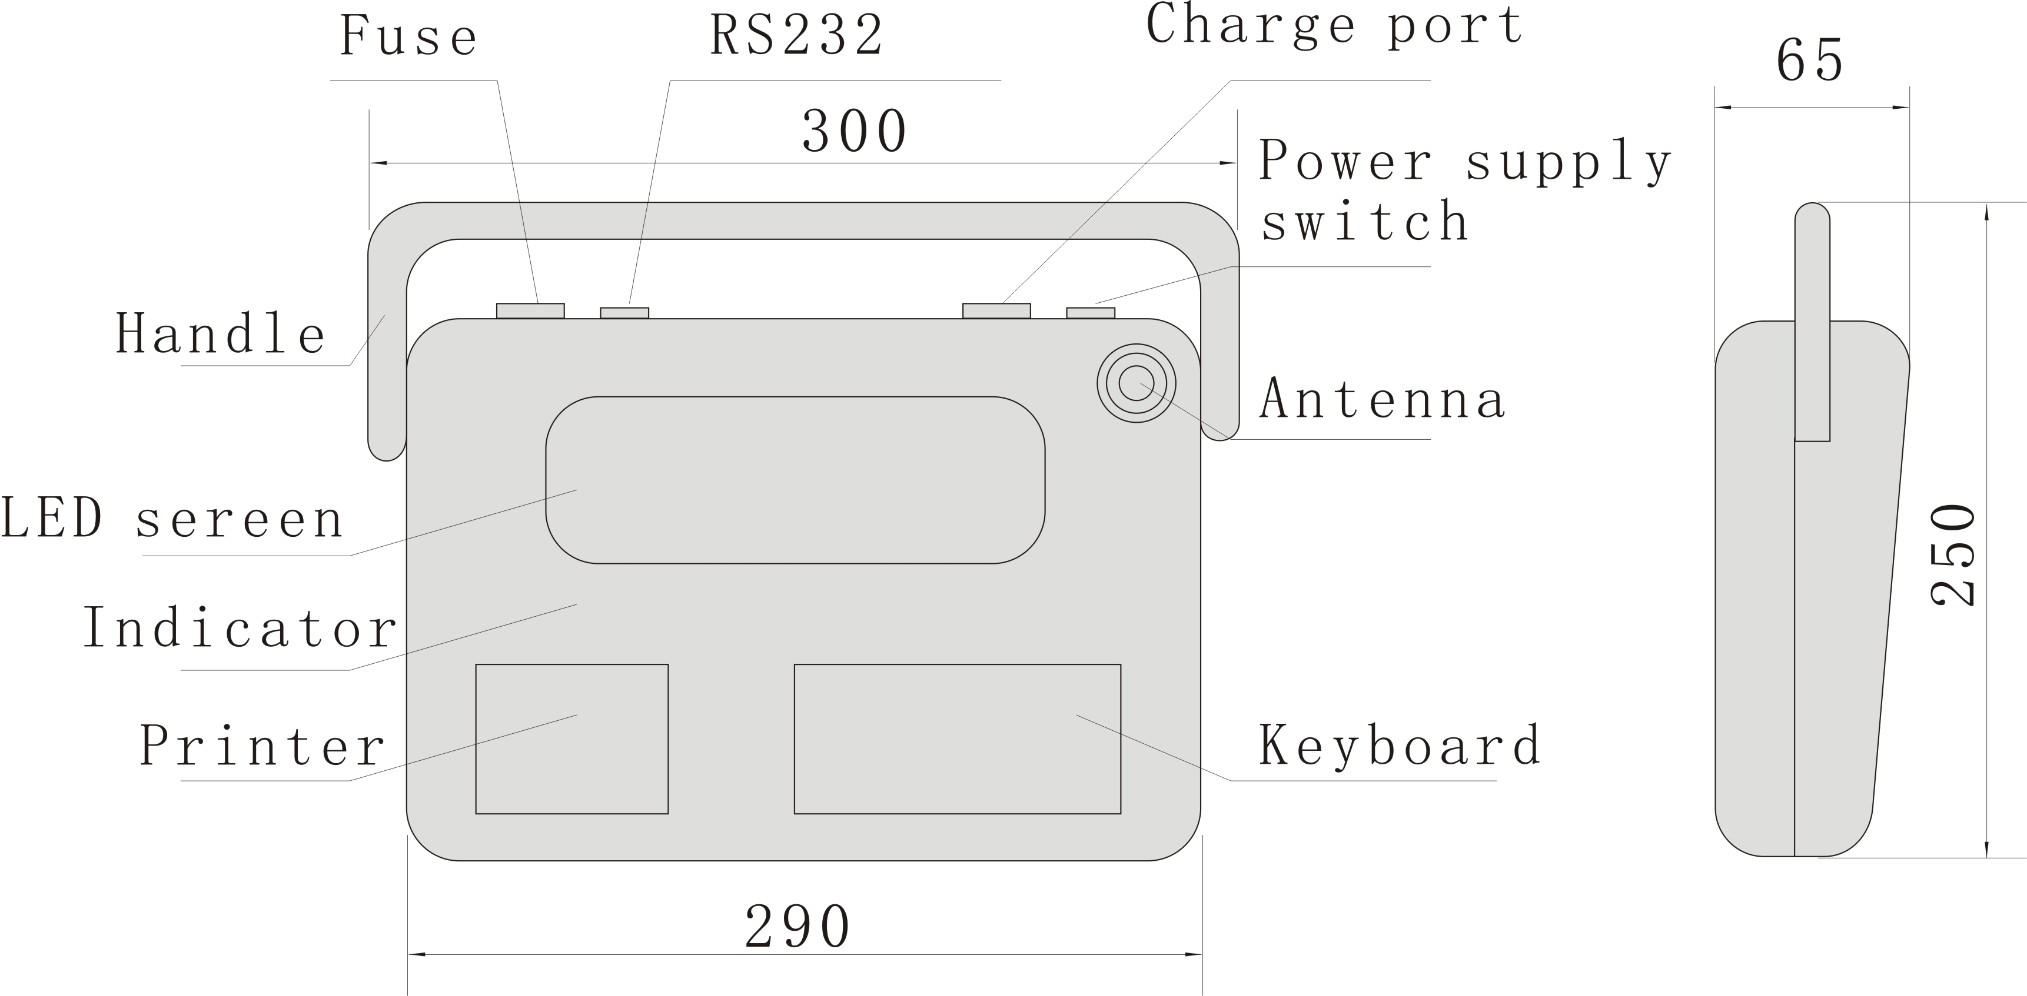
Fuse , Serial Output , Charger input, handle , LCD display, printer, power switch, antenna
- Scale

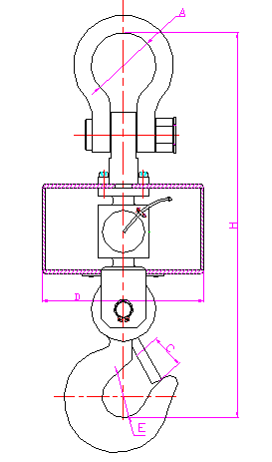
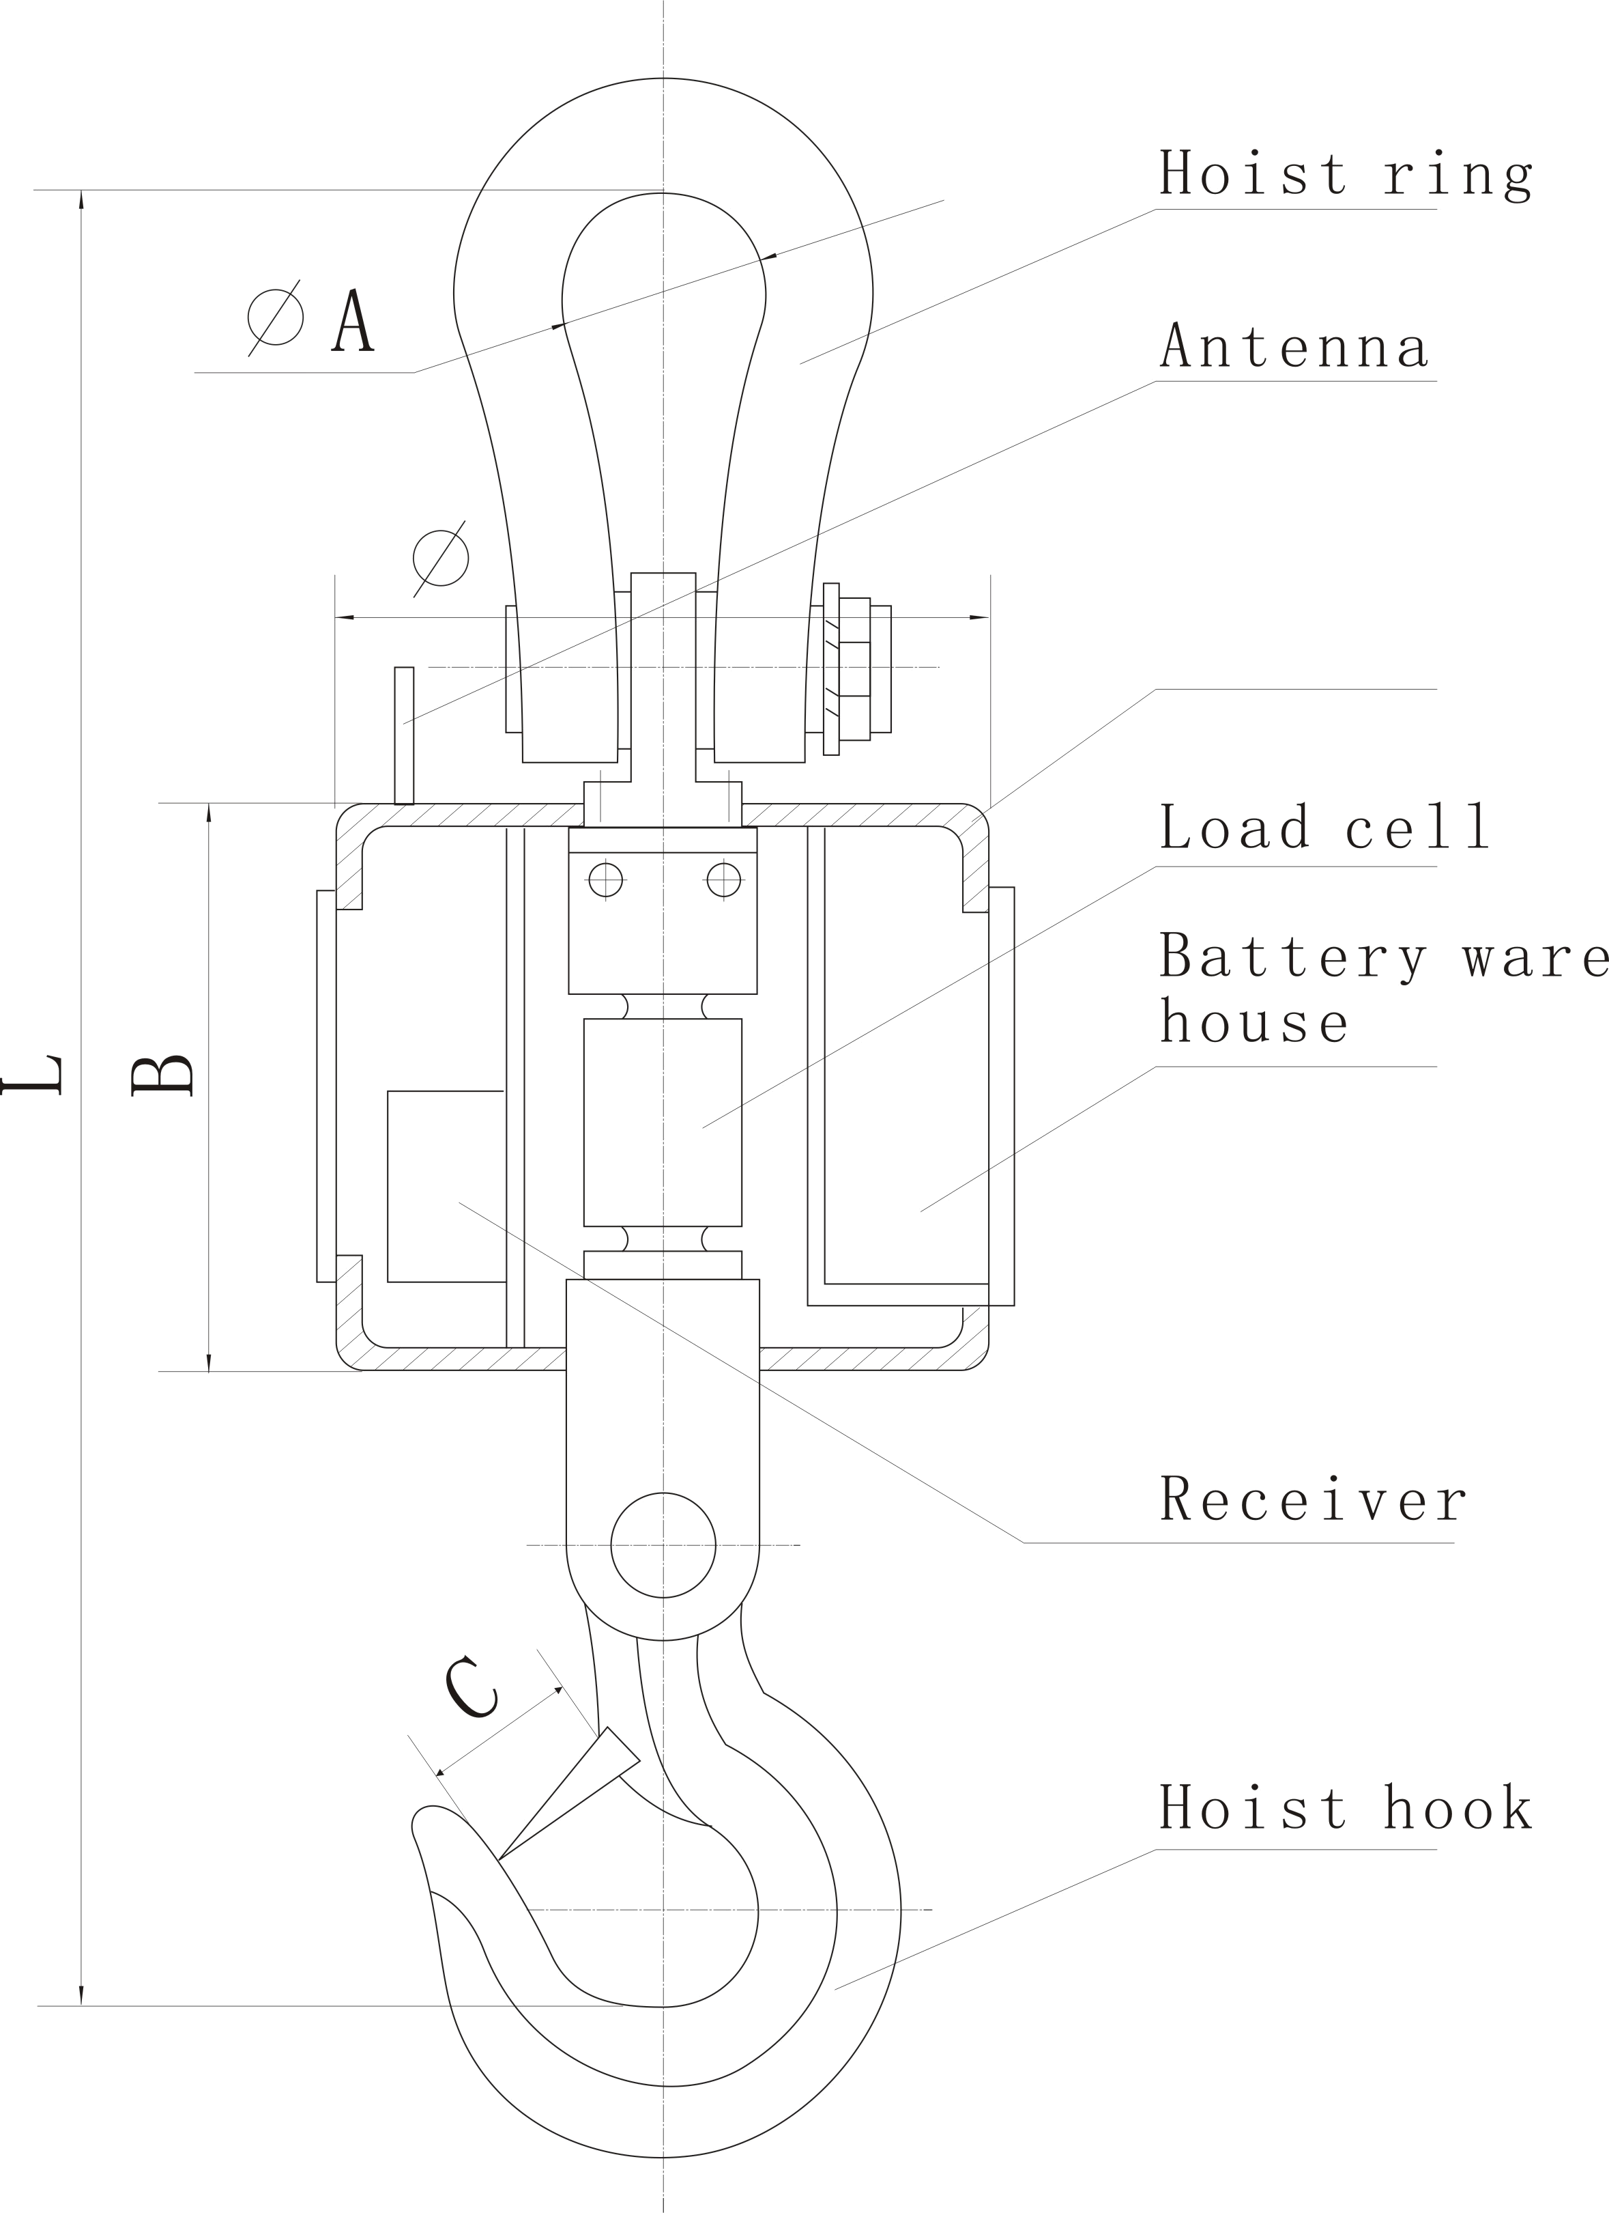

hanging hook, antenna , scale body , load transducer, A/D processor , hook ,battery housing
- Model Type
Model Type | Range t | Division kg | dimension (mm) |  |  |  |  |  | weight kg
Model Type | Range t | Division kg | A | B | C | D | E | H | weight kg
OCS-SZ-1C | 1 | 0.5 | 76 | 105 | 34 | 190 | 47 | 460 | 15
OCS-SZ-2C | 2 | 1 | 76 | 105 | 34 | 190 | 47 | 460 | 15
OCS-SZ-3C | 3 | 1 | 76 | 105 | 40 | 190 | 50 | 486 | 15
OCS-SZ-5C | 5 | 2 | 80 | 120 | 48 | 200 | 60 | 560 | 23
OCS-SZ-10C | 10 | 5 | 90 | 128 | 52 | 216 | 70 | 630 | 36
OCS-SZ-15C | 15 | 5 | 135 | 141 | 60 | 216 | 85 | 897 | 52
OCS-SZ-20C | 20 | 10 | 150 | 148 | 73 | 240 | 90 | 948 | 103

2. Key Technical Specification and Basic Parameters
- Accuracy Class: GB11883-89 (International R76 equivalent)
- Power Source: 6V/4AH Nd-H battery
- Radio Frequency: 430MHz (8 frequency band)
- Load Cell Activation Power: DC 5V±5%
- Operation Temperature: 10°~50°C and 0°~40°C for scale and indicator, respectively
- Radio Transmission distance: >200m unobstructed
- Model Specifications

Model Type | Maximum Capacity（kg） | Division  (kg) | Weight Limit（kg）
OCS-SZ-1 | 1000 | 0.5 | 1004.5
OCS-SZ-2 | 2000 | 1 | 2009
OCS-SZ-3 | 3000 | 1 | 3009
OCS-SZ-5 | 5000 | 2 | 5018
OCS-SZ-10 | 10000 | 5 | 10045
OCS-SZ-15 | 15000 | 5 | 15045
OCS-SZ-20 | 20000 | 10 | 20090
OCS-SZ-30 | 30000 | 10 | 30090
OCS-SZ-40 | 40000 | 20 | 40180
OCS-SZ-50 | 50000 | 20 | 50180

- Indicator Panel
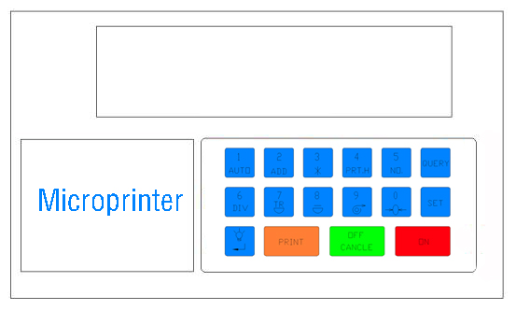

- Key Pad Functions

Keys | Function descriptions
0~9 | Numerical keys, they can also be used with other function keys
ZERO | Zero the current weight display.
Auto | Start or End auto storing or printing function.
Add | Add current stable weighing data to the internal memory, including parameters, such as sequence number, index, date and time, etc.
Total | Show the total weighing number and total weight
Print H | Print the header for the data sheet
Order | Change the current order number (0000~9999)
Division | Set the division number or the minimum display variable number
TARE | Set the known tare number (0000.0 ~9999.9)
Subtract | This function is mainly used for milling or molding application to indicate the amount of weight subtracted.
Feed | Forward the print paper for four lines without printing
Search | Search the existing weighing data
Setup | Set the system index
Backlight/Confirm | Turn on the backlighting when the display is for weight or time. Confirm for others.
Print | Print the weighing data (two types of printing method)
Off/Cancel | Turn off the indicator or cancel specified operating steps
On | Turn on power supply to the system

- Introduction - Mode of operation

Immediately after the indicator is turned on, it will go through self-check sequence, including the version of the operating interface, measurement capacity limit, then the numbers from 999999, 88888, 777777, ….to 111111. There will be 0.5 second interval between each set of numbers.
After the completion of self-check sequence, the time mode will be displayed as Fig. 1. If there is weighing signal detected, the display will change into Weigh mode from time mode as shown in Fig. 2. Otherwise the display will remain in Time mode.
09：15：45

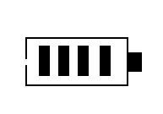

As shown in Fig. 1, the battery power level indicator is located in the upper left corner of the LCD display. Four-bar indicates the battery is at full charged full, one-bar means the battery power is low. In that case, the indicator needs to be charged to prevent it from data lost. 09:15:45 is the current time.

Auto
NO.1
0005

0．0 kg

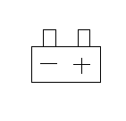

NO.1
0005

In Fig.2, RECEIVE indicates there is weighing signal detected by the indicator and the indicator is in weighing mode; AUTO means that the indicator is in automatic store and print states; STABLE means the measured weight has been at stable condition; ZERO indicates that there is 0 weight; the number under Sequence is the current weighing number (as shown as 005 in Fig. 2). Scale Power Low indicates that the scale battery needs to be changed so to maintain proper signal transmission.

- Basic Operations

The basic operations for the indicator are described below.
  - Power ON - For simple weighing operation, it can be done by following operating sequence:
    - For initial use, connect the battery of the crane scale:
1) open the battery housing using a flat-tip screw driver and connect the battery to the power cable;
2) Switch the power to ON position. The scale is powered on when a long beep is heard.
    - 30 seconds after the scale is powered on, turn on the indicator power. Press ON key on the indicator. The display will show the software version first (such as “V1.0” as shown in figure below) and then the weight value limit (as shown as “5018” in this case). After that, the display will cycle from “999999” all the way down to “111111”. If there is no weight signal received from the scale, the display will remain in Time mode as shown in Fig. 1. If there is weight signal received, the indicator will change to WEIGH mode (Fig.2).
    - After the load is craned up through the scale and STAB is continuously shown on the upper right corner of the display, the weight value displayed is the weight of the load.
V1.3
5018
999999
888888
999999 to111111conter down
111111

09：58：41

NO.1
0001
0 kg
If signal detected
  - ZERO
The indicator should show “0.0” under non load condition. In case there is residual value displayed under zero loading, such as 12kg as shown in figure below; it has to be zeroed before weighing operation. Press ZERO to zero it out. The weight display should be 0kg and ZERO is lit. Zeroing function is only effective when the residual display is less than
20% F.S. of the scale.



NO.1
0001
12 kg

NO.1
0001
0 kg
Press ZERO

  - AUTO
In WEIGH mode, press Auto key and AUTO is lit. Now the system is in automatic mode of operation for date storage and print. Press Auto key again, AUTO indicator is off. In this mode, the system is operating in manual mode. Any weight data has to be manually totaled to be saved.



NO.1
0001
0 kg

Aut Auto
NO.1
0001
0 kg

NO.1
0001
0 kg
Repress AUTO
Press AUTO

With AUTO shown on the display, each weighing result is automatically saved in the data memory after preset time delay (see Auto-print stable time setup). The result is also being printed with its weighing sequence number.
This AUTO process is illustrated in the diagram below:

NO.1
0001
0 kg
NO.1
0001
326 kg
wait for STABLE
Auto Auto
NO.1
0001
326 kg
after the preset delay
Auto Auto
NO.1
0001
326 kg

b 0005
*Note: “b 005” means that the current saving is for weighing load No. 5.

printer prints this result
Auto Auto
Load Weight

  - Add (below description is effective only without using HEADER key):

    - Manual Add – Press Add key when the system is in manual WEIGH mode (AUTO is not lit in the display), the weighing result will be saved in the internal memory which can be searched and summarized for printing. Sequence number will increase by step of 1. For the same stable weigh value, it can only be saved once.

Load Weight
NO.1
0001
0kg
NO.1
0001
326 kg
NO.1
0001
326kg

b 0005
Press ADD

    - Auto Add – Press Auto key to activate Auto Add for data saving and printing. The AUTO indicator has to be lit on the display. Under automatic operation, each non-zero stable measurement will be saved and printed automatically. However, the indicator has to be zeroed between measurements or 50 division numbers.

  - Total
In WEIGH mode, press Total key and the Total sign will light on the display. Under Total, “b 0007” is shown, for example. “b” indicates weighing and “0007” indicates the total weighing number meaning there are 7 set weighing data saved so far. Press Total again, and the display shows “H100kg”, for example. “H” indicates the data’s high digit, “100” indicates that the total weight high digit is 100. Press Total again, the display shows “L2837.0kg”. “L” means lower digits of total weight as “2837kg”. So the total weight should be 1,002,837kg. Press Off/Cancel to exit total weight display.

NO.1
0001
12kg
*
b 0007
Press TOTAL
*
H 100 kg
Press TOTAL

*
L2837.0 kg
Press TOTAL

NO.10001
12kg
Press OFF/CANCEL

  - Print Header
In WEIGH mode, press Print H will print the weighing results in the following format:

Weighting list
2004 /08/12 16：00
No.2:0005
Unit：Kg
Press PRINT HEAEDER

Press this key can also perform statistic print function. In the above example, when the indicator shows a stable weight measurement, press Print. The printer will print the following results:

Press Print
b 28

“0003” is the current sequence number and “2014” is the current load weight. Both numbers will be saved in the data memory. Sequentially, the following data set will be saved and printed with sequence number “0004”, “0005”, “0006”… Upon weighing completion, press Add, the indicator will summarize and print the total weight by the total weighing numbers, starting from Print H:
Weighting list
2003 /08/12 16：00
NO.2: 0005
Unit: Kg
0003 2000.0
0004 1500.0
0005 1000.0
0006 500.0
------------------------COUNT：4
Total： 5000.0

Press Total

Note: The scale needs to be zeroed between each weighing operation.

  - Order
When Order is pressed, Index is highlighted with the current indexing number, such as “Order 1234”. If the order number needs to be modified, use the numerical keys (0~9) to input and then press Backlight/Confirm to confirm changes or press Off/Cancel to cancel the operation. In the following example, the order number is changed from 1234 to 0018.
The modification range of order number is from 0000 ~ 9998. In case the input order number is 9999 and Backlight/Confirm is pressed, the indicator will show “52909”. “52909” is actually the current received A/D value. Press Off/Cancel to return to WEIGH mode of operation.

NO.1
0001
0kg
NO.2
1234
Press NO.2
NO.2
0018
Input NO. 0018
NO.1
0001
0kg
Press Backlight/Confirm

  - Division
Press DIV key to display the current division number. Use numerical keys 0~9 to select desired division number. Press Backlight/Confirm to confirm or Off/Cancel to cancel. The correspondence between numerical number and division number are as following:
1 – 0.1
2 – 0.2
3 – 0.5
4 – 1.0
5 – 2.0
6 – 5.0
7 – 10.0
8 – 20.0
9 – 50.0

The following example is to change the division value from 0.2 to 2.0.

NO.1
0001
12．8kg
Press Division
d 0．2
d 2．0
Press5
NO.1
0001
12kg
Press Backlight/Confirm

  - TARE
In TARE mode, use numerical keys to enter the tare value then press Backlight/Confirm. The weighing results afterward will be net weights.


NO.1
0001
678.9kg

p kg
0678.9kg
Press Tare
NO.1
0001
444.4kg

p kg
0234.5kg
Press Backlight/Confirm

In this example, 234.5kg is the tare and 444.4kg is the net.
When TARE key is pressed, the indicator will display P XXXX.Xkg. This is the current Tare weight. If there is no tare weight defined, press TARE key, XXXX.X is the current weight value. Press Backlight/Confirm to define the weight as tare. TARE indicator is lit while the net weight is displayed. With tare defined, the display will show the net weight of the load. Press TARE again to change XXXX.X to 0.0000. Now press Backlight/Conform to show the gross weight (including tare):

NO.1
0001
678.9kg

p kg
0678.9
T
NO.1
0001
0.0kg
T
NO.1
0001
333.3kg
Load Weight

p kg
0000.0 kg
NO.1
0001
1012.2kg
Press Tare
Press Backlight/Confirm

Press Backlight/Confirm

Press Tare

  - Subtract
Subtract function is specially designed for steel milling or molding operation. Under the normal weighing operation for example, the weight of a load is 567.8kg. Now enter the Subtract mode of operation by pressing Subtract so the displayed weight value becomes “0.0 kg”. When a 50kg of load is removed, the indicator will show the 50kg as subtraction. Press Subtract again, the left weight is shown (as normal weight). The diagram below shows an example of Subtract operation.


NO.1
0001
567.8kg

NO.1
0001
0.0kg
S
NO.1
0001
50.0kg
Discharge 50kg of goods
NO.1
0001
517.8kg
Repress Subtract
567.8kg
Press Subtract

  - Feed
When Feed key is pressed, the paper will be forwarded 4 lines without printing.

  - Search
When Search key is pressed, the display will show the weighing result prior to the current sequence number. Press Backlight/Confirm key, the indicator will show the weight result for the previous sequence until Sequence number 0001. If one keeps pressing Backlight/Confirm key, “nod---” will be displayed, indicating all the weighing data have been displayed already. Press Off/Cancel to return WEIGH mode. In addition, one can search any weighing result by entering the four-digit sequence number to show its weight record. Press Backlight/Confirm to continue to the previous sequence until the end. In case there is no weight record for the sequence entered, the display will show “Nod---”. Press Off/Cancel to return to WEIGH mode.

NO.1
0008
0.0kg
NO.1
0007
234.8kg
NO.1
0006
234.8kg
Press Backlight/Confirm
NO.1
0002
890.0kg
Press Backlight/Confirm after input 0002
NO.1
0001
356.5kg
Press Backlight/Confirm
nod---
Press Backlight/Confirm
NO.1
0008
0.0kg
Press Search

  - Backlight/Confirm
In WEIGH mode, press Backlight/Confirm key to turn on the backlighting. Press it again will turn the backlight off. Under other operating conditions, the key is used as confirmation. If there is no weighing activity 2 minutes after the backlight is turned on, the indicator will turn the light off to preserve battery power.

  - SET
Press SET key to enter setup mode of operation. “SET” is displayed. Press numerical key to select the desired function. The numerical key represents the function in SET mode as below:

NO.1
0008
0.0kg
SEt
A
1 – Clear
When 1 is pressed under SET mode, the last entry (the weight record with highest sequence number) will be displayed. A few seconds after, “dEC---“ is showing. Press Backlight/Confirm to clear or Off/Cancel to cancel.

A
Press 1
NO.1
0002
890.0kg
dEC---
After a few seconds
A
Press Backlight/Confirm or OFF/CANCEL

If there is no stored weight data, the display will show “nod---”. Press Off/Cancel to return to WEIGH mode.

2 – Summarize
Press 2 key under SET to enter Print Summery mode (or PRB). In the Prb menu, there are three options, PRB1, PRB2 and PRB3:
PRB1 means to print summary according to sequence number.
PRB2 means to print summary according to order number.
PRB3 means to print summery according to weighing date.
Input the desired sequence number, order and date for the summary after selecting the summary method. One can go direct printing by entering the sequence, order or date data. SUCC will be displayed upon printing completion and FAIL indicates otherwise. Regardless SUCC or FAIL, press Backlight/Confirm to return to input mode to continue. Press Off/Cancel to return to PRB mode.
    - Printing per Sequence number

A
Press 2
Prb
NO.1

0001
NO.1
0021
Input 0021
Press Backlight/Confirm and print the result
SUCC
NO.1

0001
Press1
Press Backlight/Confirm
Weighting list
2005/07/19 14：42
Unit：kg
0001 500.0
The result is below：

    - Printing per Order Number

Press 2
Prb
NO.2

0001
NO.2

1234
Press Backlight/Confirm and print the result

SUCC
Press 2
Press OFF/Cancel
A
Input 1234
Prb
The result is below:
Weighting list
2005/07/19 14：55
NO.2：1234
Unit：kg
0002 1500.0
0003 2999.0
------------------------
COUNT ： 0002
Total： 4499.0

    - Printing per Weighing Date (insert Diagram)

Press 2
Prb
Date

000001
Date
050719
Press Backlight/Confirm and print the result

SUCC
Press 3
Press OFF/Cancel

Input 050719
Prb
The result is below:
Weighting list
2005/07/19
Unit：kg
0001 500.0
0002 1500.0
0003 2999.0
0009 1000.0
------------------------
COUNT ： 0004
Total ： 5999.0
A

3 – Total Clear
Press 3 under SET menu, the total number of weighing and the total weight are shown first. In the below example, “0003” indicates the total number of weighing and “4990.0” is the total weight. After about 2 seconds, the “Clr---“ comes up. Press Backlight/Confirm to clear all the existing data in the memory. Press Off/Cancel to quite. After clearing, the current sequence becomes 0001.

A

0003
4990.0kg
Clr---
After a few seconds
A
Press Backlight/Confirm or OFF/Cancel

Press3

4 – Set Date
Press 4 to show the current date: i.e.05.02.18 (mm/dd/yr)
Please follow the below example for date change.

A
A
Date
041124
Press4
Date

050719
Input date 050719
Press Backlight/Confirm

5 - Set Time
Press 5 key to show the current time: i.e. 08:48:21


A
081156
Press 5按5
150103
Input date 150103
Press Backlight/Confirm
A

6- Zero Range
Press 6 key under SET menu, “O 100” is shown. “O” is the high digit which indicates the initial zero range at power up. The low digit indicates the exact zero range (%FS). For example, “10” means that any drift value which is less than 10% FS will be directly zeroed. The selections of zero range at power up are as below:
1 – 2%
2 – 10%
3 – 20%
4 – 50%
5 -100%
In the example below, the zero range is changed from 20% FS to 100%FS:

A
o
20
Press6
Press5
Press Backlight/Confirm

A
o
100

0 – Others to enter submenu (password required)
Press 0 key to enter submenu. After “PAS” prompt, enter the correct password then press Backlight/Confirm. SS indicates the entry of secondary menu.

A
Press0
PAS
SS
Press Backlight/Confirm after input password
B

There are below selections:
★ Set Weight Limit
After Select 1 in Subset menu, “SSU1 5018kg” is displayed, for example. Here “SSU1” indicates that the 1st item in the Subset menu is selected and “5518” is the weight capacity limit of the scale. To modify this number, input the new value and press Backlight/Confirm to finish. Otherwise Off/Cancel to quit.
In the below example, the weight capacity limit is changed from 3009kg to 5018kg.

B

SSU1
3009kg
Press 1

SSU1
5018kg
Input 5018
Press Backlight/Confirm
B

★ Calibration
When 2 key is pressed under Subset menu, “noloAd” is shown, indicating the system is in calibration mode. The calibration procedure is as below:

Linear Calibration:
Removal any load from the digital scale. After the system is in calibration mode and “noLoAd” is shown, press Backlight/Confirm to start calibration. The display will show “XXXXXXX” which is the internal code for zero. After the code is stable and “Load1” is shown, the display will go blank within 2 seconds. Now enter the load weight value. Press Backlight/Confirm. The display will show “YYYYYY” which is the internal code for the load weight #1. After the code display becomes stable, press Off/Cancel to complete the one-time linear calibration between 0 and Load1. If Backlight/Confirm is pressed, the system is going to non-linear calibration. The following example is the linear calibration process for a 5-ton crane scale:
B
Press 2
noloAd
Press Backlight/Confirm with non-load
确认
5245
Press Backlight/Confirm
LoAd1
After a few seconds
SSU1
5000
SSU1
Load 5-ton weight and input 5000
Press Backlight/Confirm

591144
Press Backlight/Confirm

LoAd2
B
Press OFF/Cancel
Non-linear Calibration:
Continuing from the linear calibration, press Backlight/Confirm key when “Load2” is displayed. Now the weight value of Load2 should be entered, and then press Backlight/Confirm key. Now the “ZZZZZZ” will show. ZZZZZZ is the internal code for Load 2. After the internal code becomes stable, the display will show “Load3”. If a three-point nonlinear calibration (0, Load 1 and Load 2) is desired, press Off/Cancel to complete. Otherwise press Backlight/Confirm. When the LCD display goes blank, enter the weight value for Load3 and then press Backlight/Cancel. The internal code for Load3 is showing. After the display becomes stable, press Backlight/Confirm to complete the four-point nonlinear calibration.
Below is an operating example that a 20-ton crane scale is non-linear calibrated with 3-ton, 8ton and 20-ton weight.
B
Press 2
noloAd
Press Backlight/Confirm with non-load
5245
Press Backlight/Confirm
LoAd1
A few seconds later
Lod1
3000
Lod1
Load 3-ton weight and input 3000
Press Backlight/Confirm

151416
Press Backlight/Confirm

LoAd2
Press Backlight/Confirm

LoAd1
Lod1
8000
Lod2
Load 8-ton weight and input 8000
Press Backlight/Confirm

257279
LoAd2
Press Backlight/Confirm

LoAd3
Lod3
Press Backlight/Confirm

★ Change Password
In Subset Menu pressing 3 key, enter the new password when “PAS1” is shown. Press Backlight/Cancel upon completion. Enter the new password one more time when the display is showing “PAS2” and press Backlight/Confirm. If both passwords entered are identical, the password modification is complete. Otherwise return to Subset Menu and repeat the above process to complete the password modification.
Below example is showing the procedure to change the password to “123456”.

B
B
PAS1
Press 3
123456
PAS1
Enter the new password 123456
PAS2
Re-enter the new password
123456
PAS2
Press Backlight/Confirm

Press Backlight/Confirm

.
★ Zero-point Track Range
When 4 key is pressed under Subset menu, TO 1 is displayed. “TO” indicates the range of zero point tracking and the digit “1” indicates the detail of this range. There are several selections with their correspondence with the numerical keys.
1 – Off
2 – Small
3 – Moderate
4 – Large

The below example is to change the tracking range from Off to Small.

B
Press 4
1
TO
2
TO
B
Press Backlight/Confirm

Press 2
★ Filter Setup
Press 5 key in Subset menu to enter Filter Setup. The display, for example, is “F 30”. “F 30” is the extent of filtering. If no filtering change is needed, press Off/Cancel to quit. Otherwise press Backlight/Cancel to proceed to Filter Setup. In the example below, the filter is set from 30 to 40.

30
F
40
F
Press 5
Press40
B
Press Backlight/Confirm

★Auto Print Setup
In Subset menu, press 6 key. The display is “A1 05.2”, for example. Here “05.2” indicates that the auto-printing will start 5.2 seconds after the weighing completion (or the weight measured becomes stable). If no modification is needed, press Backlight/Confirm otherwise, enter the desired time (0.1~99.9) and press Backlight/Confirm to complete. Now, “A2 0.5” will be shown. Here “0.5” means the data variation range in division, within which it is considered stable during measurement. In this case, the stable range is 0.5 of one division. If no change, Backlight/Confirm to quit. Otherwise enter the new value (0.1~999.9). Press Backlight/Confirm to complete.
In the following example, the auto-print time delay is changed from 5.2 seconds to 3 seconds and the stable range is from 0.5d to 1d.

05.2
A1
03.0
A1
Press 6
Enter030
B
Press Backlight/Confirm

000.5
A2
001．0
A2
Enter 0010
Press Backlight/Confirm

★Printer Setup
In Subset menu, press 7 key. The display shows “PS 1”. “PS” is the printer setup and “1” indicates that there is a printer (“0” means there is no printer). Enter “0” to skip printing or enter “1” to select printing. Press Backlight/Cancel to return to Subset menu.

B
0
PS
1
PS
Press 1
Press 7
Press Backlight/Confirm

B

★ Indicator Exchange
Press 8 key in Subset Menu and the indicator shows “XXXXXX”. XXXXXX is the calibration factor. If there is no change, press Backlight/Confirm. Otherwise enter the new factor then Backlight/Confirm. Now the display shows “E X”. X can be 0, 1 or 2 with the following implications:
When X=0: if XXXXXX is 123456, then the calibration factor is 123456.
When X=1: if XXXXXX is 123456, then the calibration factor is 1234560.
So X is the power of 10 for the calibration factor.
Press Backlight/Confirm to complete the indicator exchange process.
In the example below, “928637” is the calibration factor. In the example, the calibration factor is changed to 1021500. Since the ratio between 1021500/928637 =110%, the change will result in weight display change of more than 10% from the old factor. Since the LCD display can only display 5 digits, so only 102150 is entered but change the E value to 1 (10x).

B
928637
Press 8
102150
Enter 102150
Press Backlight/Confirm

E 0
E 1
Press 1

- Battery Charging Method

Both scale and indicator are powered by the batteries. For the scale, the battery can be charged either while it is installed on-scale or it can be taken out of scale and charged. Battery should be charged promptly once the indicator power monitor shows the low battery power. This is to prolong the battery life without over discharge. The power supply for the charger is 220V. It will take over 5 hours to fully charge the battery (depending on the battery power level at the time of charge).
- Precautions
Digital crane scales are precision measurement equipments. Proper maintenance is important to prolong their usable lifetime. Please note the following:
    - Read carefully the user guide before operating the scale and the indicator.
    - Do not overload the scale.
    - The crane motion should be up/down in vertical fashion. Do not drag or carry the weight load through the scale.
    - The scale can not be used extensively under high ambient temperature. Even with thermal isolation apparatus, effort should be made to minimize the scale’s heat exposure. A rule of thumb is to the scale body is cool enough to touch (or below 70° C) so it can operate normally.
    - Avoid hard banging and wafer from the scale.
    - Avoid personal injury by properly hanging of the scale body.
    - Minimize the usage of backlighting to preserve battery power.
    - Nd-H batteries are used for the scale and the indicator. Do not operate under low charge condition to prolong battery life. It is recommended that the battery to be disconnected from the scale if the scale is inactive for over 20 hours. Power off the indicator main if it is inactive for over a week. Charge the batteries each month even without usage.
    - The indicator should be stored under dry and cool environment.
    - Use only the supplied charger and avoid over charging.
    - Handle gently the indicator handle.
    - Keep a safe distance when operating the crane scale from the weight load to prevent personal injury from falling objects.
    - For Subset menu operation, do not attempt to alter the setup without proper training.
    - Please contact us if the scale needs to be calibrated.

- Trouble- shooting
    - Beeper continuous beeps – load weight is exceeding the weight capacity of the scale. Please reduce the weight of load for normal operation.
    - The indicator shows only the time but no weight number – no signal reception from the scale. Please check if the A/D convert is properly connected and the battery is properly charged (>6Volts). If there is no reception within 10 meters, please check if the scale antenna has good contact or if it is damaged. Use backup antenna if needed.
    - The indicator has no display even LCD screen is lit. It is either due to a bad or lowly charged battery. If the problem persists after recharge of the battery, change the battery.
    - If the indicator receives signal from the scale, however the weight display remains at 0 regardless of the weight, please follow the instruction on page ?? . Enter 9999 and press Backlight/Confirm. Then pull the scale slightly to see if there is change in internal code. If there is no change, it indicates that the transducer (or load cell) has bad contact. Please check the connection wire.
    - During the printing process, if there is only printing sounds without paper out, then there is no more printing paper. Please reload. To load the paper, please following these steps:
      - Turn off the power supply and open the printer cover.
      - Feed the paper through the entry slot. Turn on the power and press Feed. The printer paper should feed automatically.
      - Close the printer cover.
    - If the indicator displays “ERROR0” at power on and no head printing with Print H, they indicate that the printer for the indicator is broken. Please contact the vendor for a new printer.
    - In case the printing is illegible, the color ribbon need to be changed:
      - Open the printer cover
      - Carefully remove the old color ribbon. Do not touch the printer bearings.
      - Insert the new ribbon box gently into the left end of bearing axis with right side slightly up. If the ribbon box is not reach the bottom, please press the knob on the ribbon box and rotate slightly by following the arrow indicator. Until the left side of ribbon box hits the bottom, low the right end of the box.
      - Check if the ribbon is straight. If not, please rotate the knob on the left side of ribbon box to straight it out.
      - Reinstall the printer cover.
Please note:
The printer model and its accessories are as below:
- Roll paper: width: 44.5±0.5mm, thickness 0.07mm. Roll paper OD is <40mm.
- Ribbon: EPSON ERC-05.
- Printer: EPSON-150II.

- After Sale Service
Please feedback any problem encountered during the usage of the scale to our sales representative. This will ensure us to provide timely technical support and quality service. Please do not attempt to fix the problem which may void the existing warranty.

- Packaging List

Item | Name | Quantity
1 | OCS-SZ | 1
2 | Scale | 1
3 | Instrument Box | 1
4 | Ribbon (ERC-05) | 1
5 | Printer Paper | 2
6 | Indicator Battery Charger | 1
7 | Scale battery Charger | 1
8 | User’s Guide | 1

